**5.17 Use Case 17 – Search for Users**

**5.17.1 Fully Dressed Use Case**

|  |  |  |
| --- | --- | --- |
| Use Case ID: | UC17 | |
| Use Case Name: | Search for Users | |
| Created By: | Philip Lim | Last Updated By: Philip Lim |
| Date Created: | April 2, 2016 | Last Revision Date: April 4, 2016 |
| Actor(s): | Administrator | |
| Goal/Actor Goals: | Obtain access to data related to a user through search criteria. | |
| Description/Summary: | An administrator wishes to gain access to information related to a user through search criteria such as the user’s ID, username, first name, last name and net name. | |
| Preconditions: | * User must be logged in as an Administrator. | |
| Post-conditions: | * A list of student(s) that fits the search criteria is created. * The list is displayed as being editable to the administrator. | |
| Minimum Guarantee: | The system does not find any users matching the specified criteria and indicates that no results have been found. | |
| Basic Flow: | 1. Administrator specifies the search criteria in available search fields. 2. System displays a list of editable users matching the search criteria indicated by the administrator. | |
| Risk assessment: | Medium | |
| Importance assessment: | 2/5 | |

The administrator wishes to search for one or many particular user(s) in the system. To do so, the administrator, through the user management page, specifies the search criteria and indicates that the search if ready to be performed. Upon completion of the search, the administrator will be able to view the result of the search. More precisely, a table of users matching the search criteria is displayed for the administrator.

**5.17.2 System Sequence Diagram**

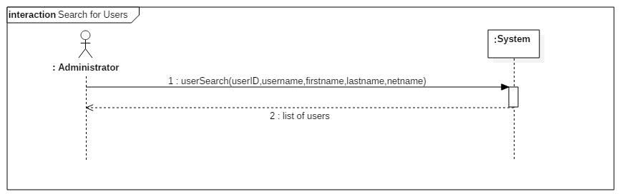

*Figure 5.17.1 Search for Users System Sequence Diagram*

**5.17.3 Contract Diagram**

|  |  |  |
| --- | --- | --- |
| Contract 17.1 | userSearch | |
| Created By: | Philip Lim | Last Updated By: Philip Lim |
| Date Created: | April 2, 2016 | Last Revision Date: April 4, 2016 |
| Operation: | userSearch(userID, username, firstname, lastname, netname) | |
| Cross-reference: | UC17 | |
| Preconditions: | * User is logged into the system as an Administrator. | |
| Post-conditions: | * A list of student(s) that fits the search criteria is created. * The administrator can access the list. | |

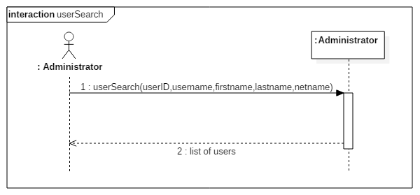

*Figure 5.17.2 userSearch contract diagram*

**5.18 Use Case 18 – View User**

**5.18.1 Fully Dressed Use Case**

|  |  |  |
| --- | --- | --- |
| Use Case ID: | UC18 | |
| Use Case Name: | View User | |
| Created By: | Philip Lim | Last Updated By: Philip Lim |
| Date Created: | April 2, 2016 | Last Revision Date: April 4, 2016 |
| Actor(s): | Administrator | |
| Goal/Actor Goals: | View information stored in the system about a user. | |
| Description/Summary: | An administrator wishes to view the profile summary that contains information about a user such as its ID, username, first name, last name, and net name. | |
| Preconditions: | * User must be logged in as an Administrator. * A user search result is displayed. * The user the administrator is looking for is listed in the search result. | |
| Post-conditions: | * The administrator has access to consult information about the user | |
| Minimum Guarantee: | The set of information field is displayed but may contain empty fields. | |
| Basic Flow: | 1. Administrator indicates that the information about a particular user displayed on a search result is to be consulted. 2. System retrieves information about the user and displays it in a table. | |
| Risk assessment: | Medium | |
| Importance assessment: | 3/5 | |

The administrator wants to view the profile of a user. In order to do so, the administrator indicates which user is to be displayed through a search result table containing one or many users. A page containing the detailed profile of the indicated user is then displayed for the administrator to consult.

**5.18.2 System Sequence Diagram**

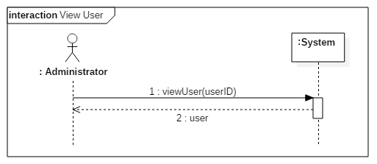

*Figure 5.18.1 View User System Sequence Diagram*

**5.18.3 Contract Diagram**

|  |  |  |
| --- | --- | --- |
| Contract 18.1 | viewUser | |
| Created By: | Philip Lim | Last Updated By: Philip Lim |
| Date Created: | April 2, 2016 | Last Revision Date: April 4, 2016 |
| Operation: | viewUser(userID) | |
| Cross-reference: | UC18 | |
| Preconditions: | * User is logged into the system as an Administrator. * The ID of the user passed is a valid and existing user ID. | |
| Post-conditions: | * User corresponding to the passed user ID is made available for the administrator to consult. | |

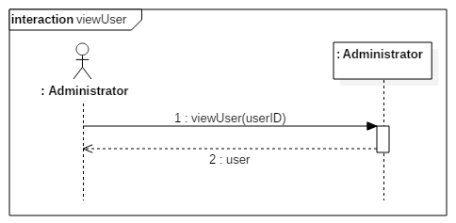

*Figure 5.18.2 viewUser contract diagram*

**5.19 Use Case 19 – Update User**

**5.19.1 Fully Dressed Use Case**

|  |  |  |
| --- | --- | --- |
| Use Case ID: | UC19 | |
| Use Case Name: | Update User | |
| Created By: | Philip Lim | Last Updated By: Philip Lim |
| Date Created: | April 2, 2016 | Last Revision Date: April 4, 2016 |
| Actor(s): | Administrator | |
| Goal/Actor Goals: | Update information related to a user. | |
| Description/Summary: | An administrator wishes to update information saved about a user. Those include the username, first name, last name, net name and privilege. | |
| Preconditions: | * User must be logged in as an Administrator. * A user search result is displayed. * The user the administrator wishes to update is listed in the search result. | |
| Post-conditions: | * Information about the user is updated. * Updated information is displayed to the administrator. | |
| Minimum Guarantee: | The user’s profile fails to be updated and an error is displayed. | |
| Basic Flow: | 1. Administrator indicates that the information about a specific user must be updated. 2. System displays the update fields filled with the current information about the selected user. 3. Administrator changes and saves the new information about the user. 4. System displays the updated profile of the user. | |
| Risk assessment: | Medium | |
| Importance assessment: | 3/5 | |

The administrator needs to update some information about a user of the system. In order to accomplish that task, the administrator first indicates that a specific user needs to be updated. Editable fields corresponding to the user’s information are then displayed for the administrator to change. Once the changes done, the administrator indicates that the changes have been completed. If the changes are valid, the updated profile of the user is displayed, otherwise, the administrator receives an error message.

**5.19.2 System Sequence Diagram**

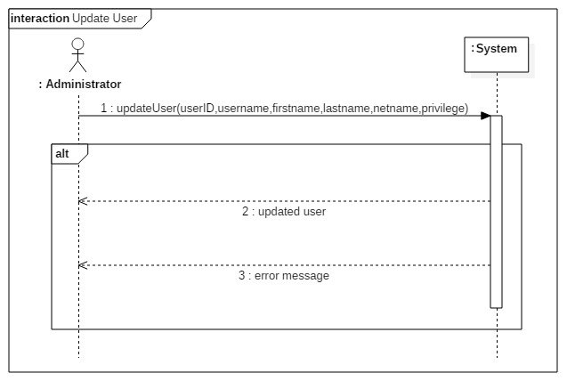

*Figure 5.19.1 Update User System Sequence Diagram*

**5.19.3 Contract Diagram**

|  |  |  |
| --- | --- | --- |
| Contract 19.1 | updateUser | |
| Created By: | Philip Lim | Last Updated By: Philip Lim |
| Date Created: | April 2, 2016 | Last Revision Date: April 4, 2016 |
| Operation: | updateUser(userID, username, firstname, lastname, netname, privilege) | |
| Cross-reference: | UC19 | |
| Preconditions: | * User is logged into the system as an Administrator. * A search result is displayed * The user that corresponds to the userID is displayed on the search result | |
| Post-conditions: | * The user’s information is updated with the new one passed as parameters. * Administrator has access to consult the updated user | |

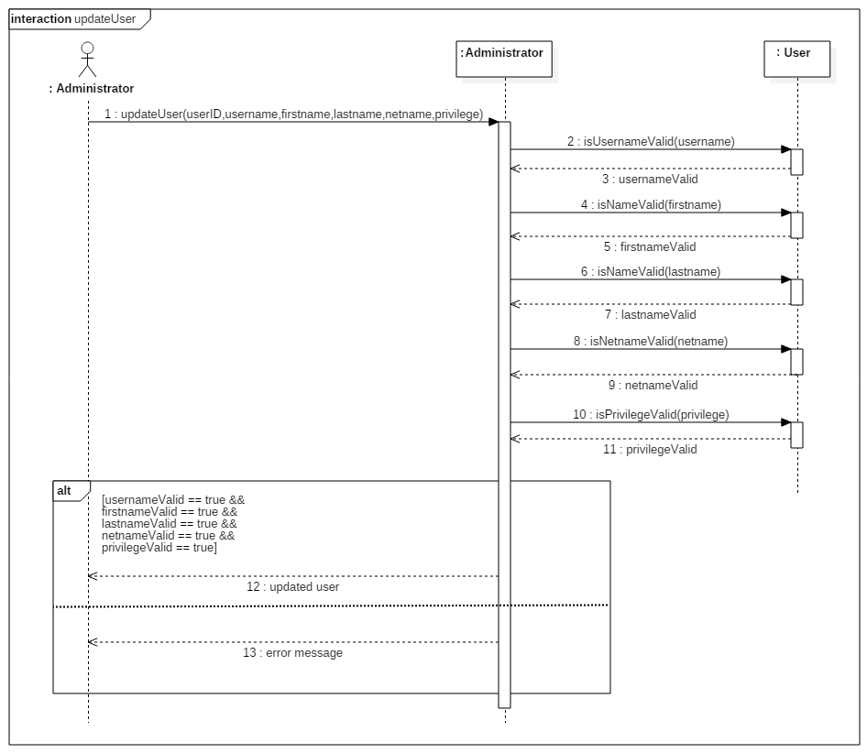

*Figure 5.19.2 updateUser contract diagram*

**5.20 Use Case 20 – Delete User**

**5.20.1 Fully Dressed Use Case**

|  |  |  |
| --- | --- | --- |
| Use Case ID: | UC20 | |
| Use Case Name: | Delete User | |
| Created By: | Philip Lim | Last Updated By: Philip Lim |
| Date Created: | April 9, 2016 | Last Revision Date: April 9, 2016 |
| Actor(s): | Administrator | |
| Goal/Actor Goals: | Delete a user from the system. | |
| Description/Summary: | An administrator wishes to delete a user (its account, and all related information) from the system. | |
| Preconditions: | * User must be logged in as an Administrator. * A user search result is displayed. * The user that the administrator wishes to delete is part of the displayed search result. | |
| Post-conditions: | * Targeted user is deleted. * Updated table of users is generated. * Updated table of users is displayed to the administrator. | |
| Minimum Guarantee: | The administrator cancels the deletion and the user remains on the system. | |
| Basic Flow: | 1. Administrator indicates that a user must be deleted. 2. System displays a message to confirm the deletion of the user. 3. Administrator confirms the deletion. 4. System displays an updated table of users to the administrator. | |
| Risk assessment: | Medium | |
| Importance assessment: | 3/5 | |

The administrator needs to delete a user from the system. To do so, the administrator needs to indicate which user is to be deleted, and confirm the action to be undertaken. Once completed, an updated table of users without the deleted user is displayed to the administrator.